Server query optimizer

SQL stored procedure

# About project

Instead of sending multiple SQL statements from the client to the server, I encapsulate them in a stored procedure on the server and send one statement from the client end to execute them.

**Benefits~~:~~** Stored procedures can be useful if you have an SQL query that you write and execute over and over again. You can save it as a stored procedure, and then just call it to execute it directly in the database server. In stored procedures, you can also pass parameters so that a stored procedure can act based on the passed parameter values.

**Project case study:** I business dealing on pet sales wants to automate the price update of pets on based on the present health status of the pet(good, bad, worse), they could not keep determining this price manually as that would take a lot of time with their database hosted on the cloud(IBM Db2). The task is-How can this business automate the price update of a particular pet given its health status? That is the question this project aims to answer. I created a stored procedure routine named **UPDATE_SALEPRICE** with parameters **Animal_ID** and **Animal_Health**.

* This **UPDATE_SALEPRICE** routine contains SQL queries to update the sale price of the animals in the PETSALE table depending on their health conditions, **BAD** or **WORSE**.
* This procedure routine takes animal ID and health condition as parameters which will be used to update the sale price of animal in the PETSALE table by an amount depending on their health condition. Suppose:
* For animal with ID XX having BAD health condition, the sale price will be reduced further by 25%.
* For animal with ID YY having WORSE health condition, the sale price will be reduced further by 50%.
* For animal with ID ZZ having other health condition, the sale price won't change.

# Skills utilised

SQL

Database

management

Cloud

computing

API

CALLS

**Software used: IBM Db2 cloud database**

Project screenshots and explanations

Next five slides

## Create database

This was what the database looks like in IBM Db2 database instance. The table shown contains list of different pets with their prices and quantity in stock. I retrieved the table with a VIEW call that retrieves all the the data in the original table.

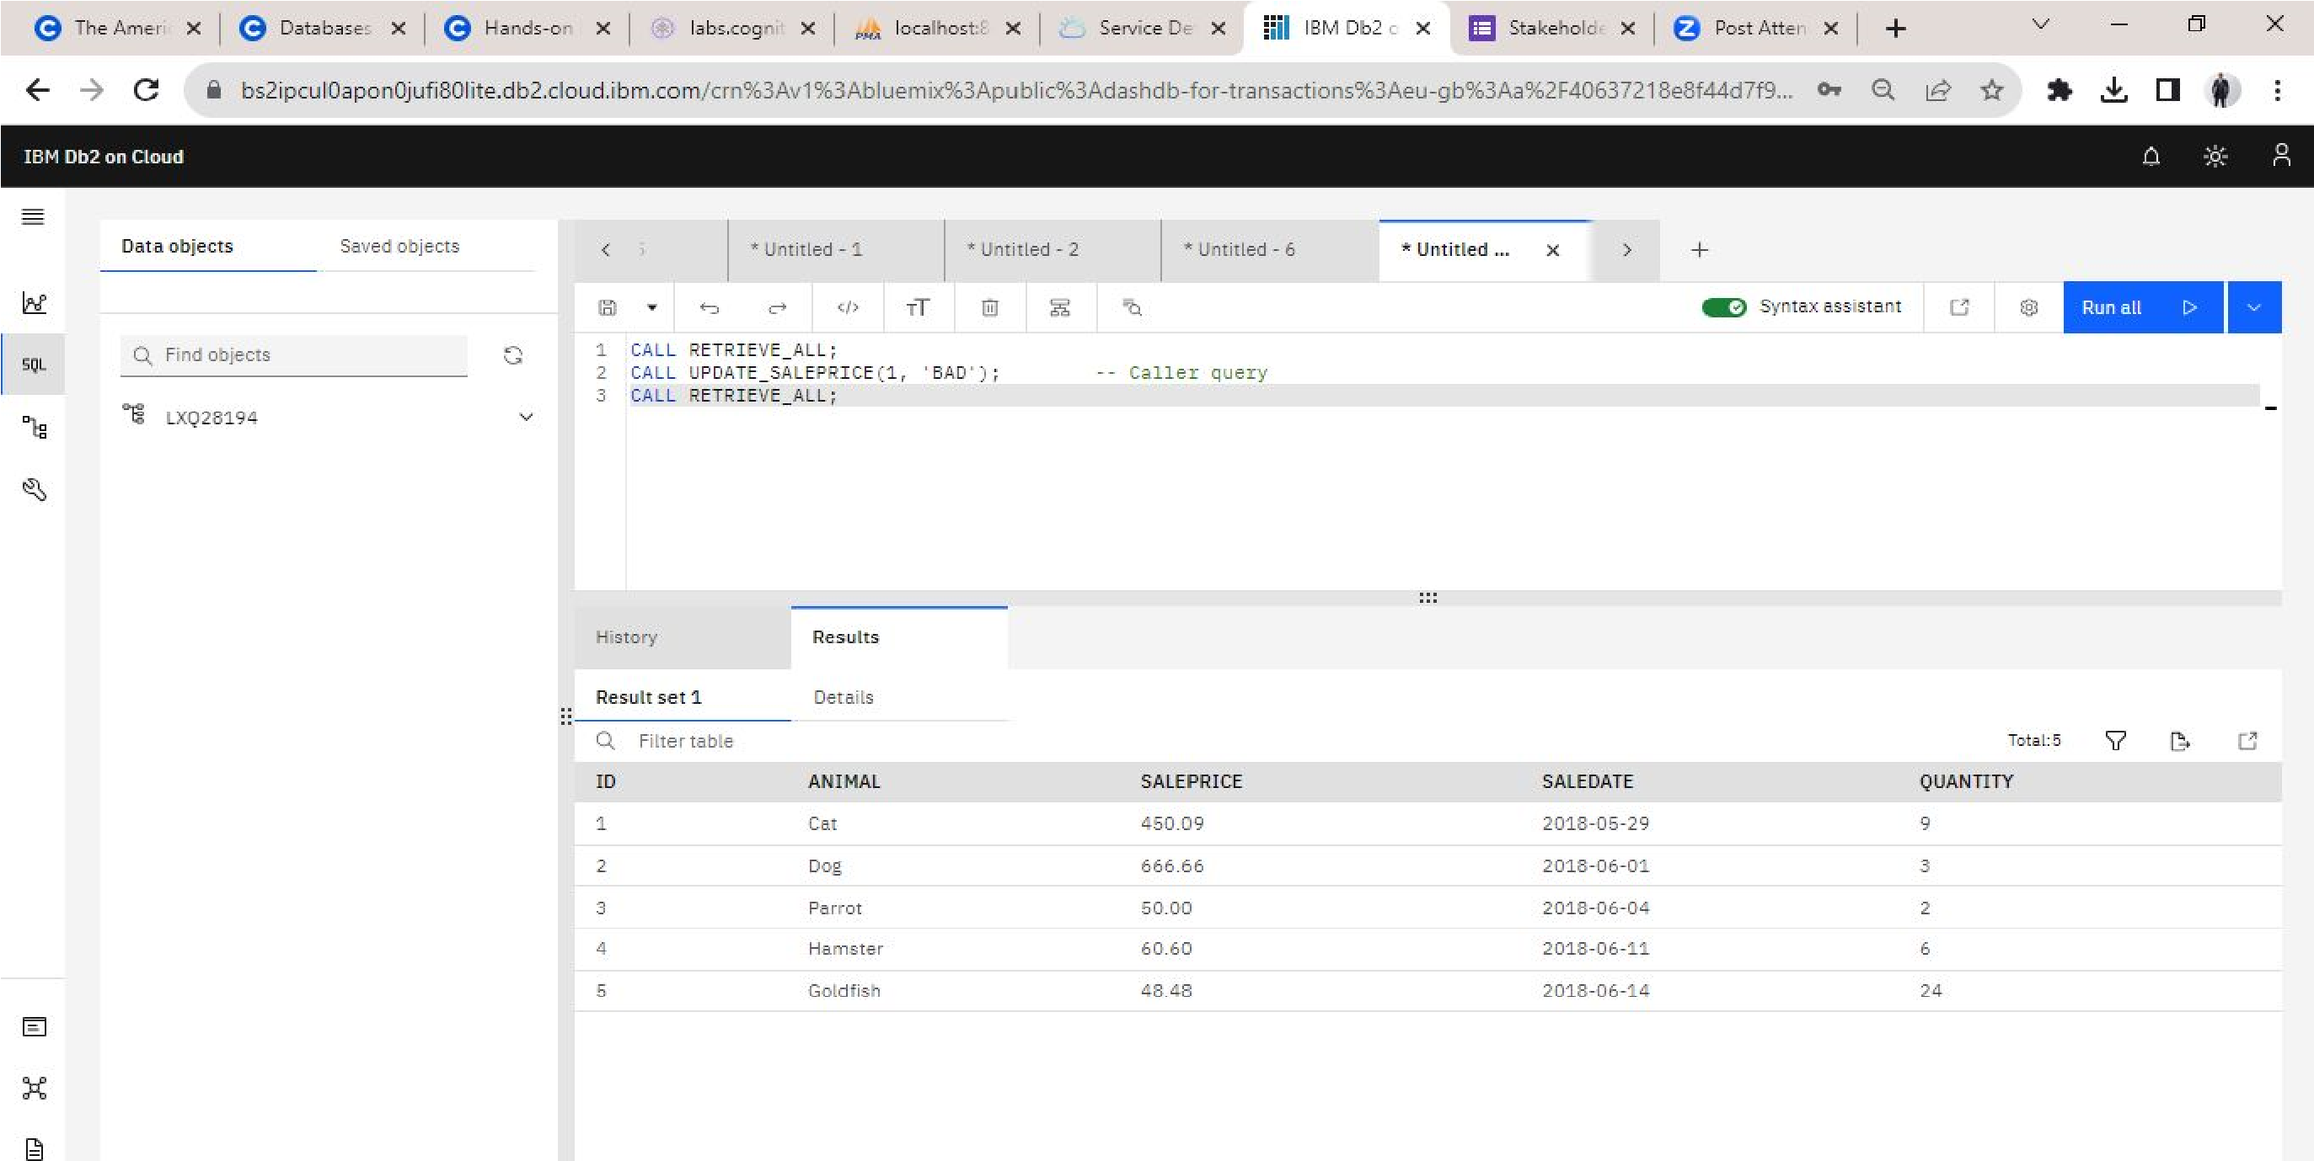

## Create Stored Procedure and save in the server

This is screenshot of the stored procedure and the SQL successfully created, ran and stored in the server

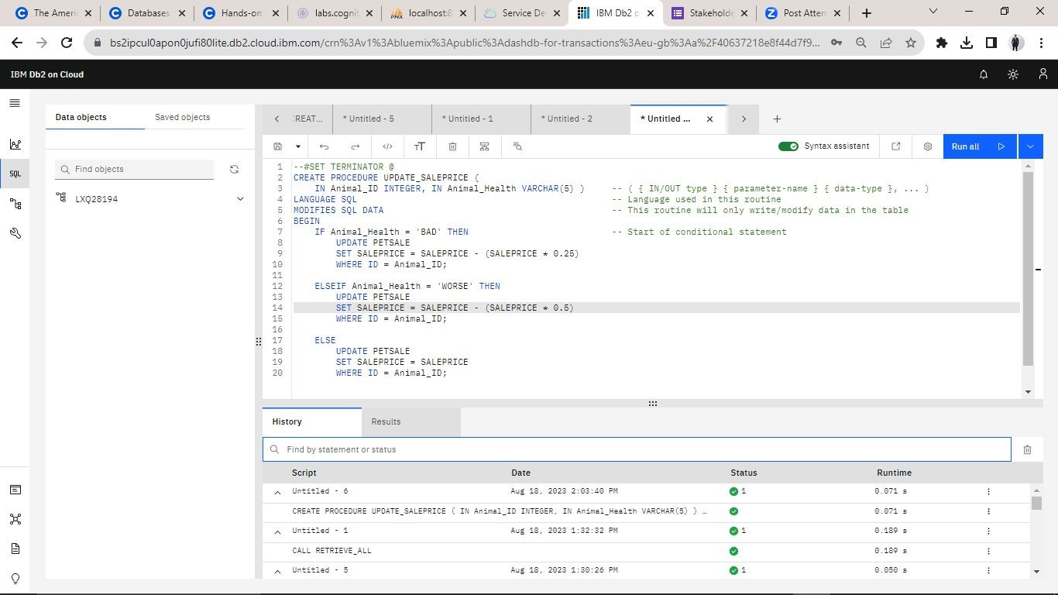

## Confirm the stored procedure is saved on the server

This screenshot shows on the left hand side that the UPDATE_SALESPRICE Procedure now exists in the database server and ready to run when called

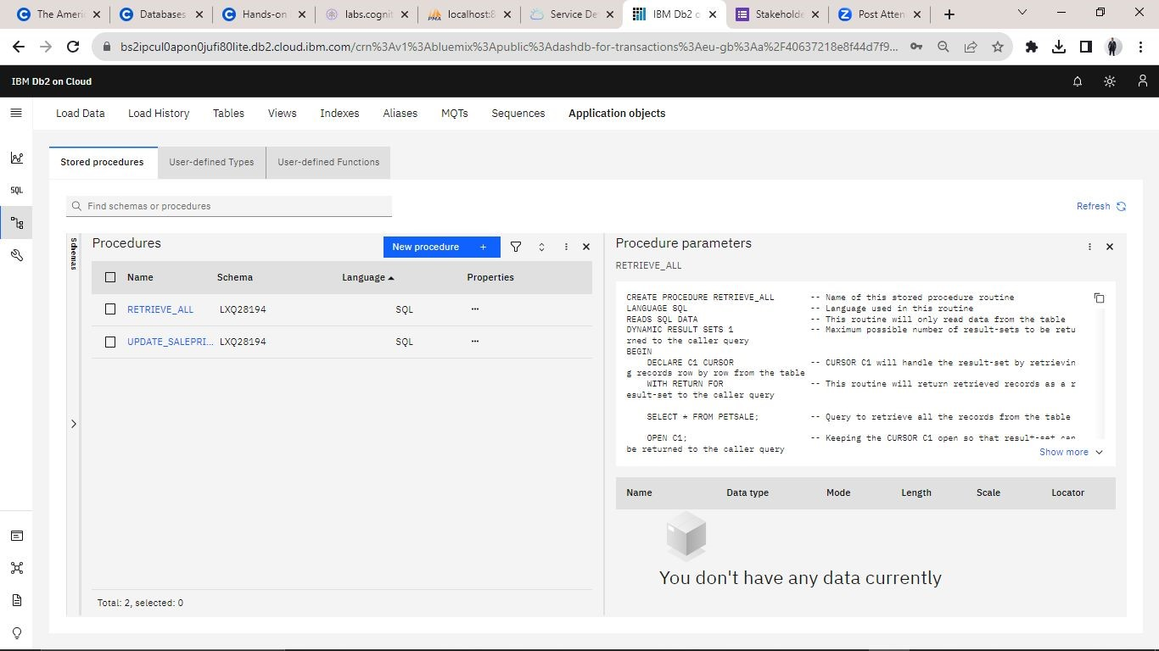

## Call stored Procedure for PET ID ‘1’ and health condition ‘BAD’

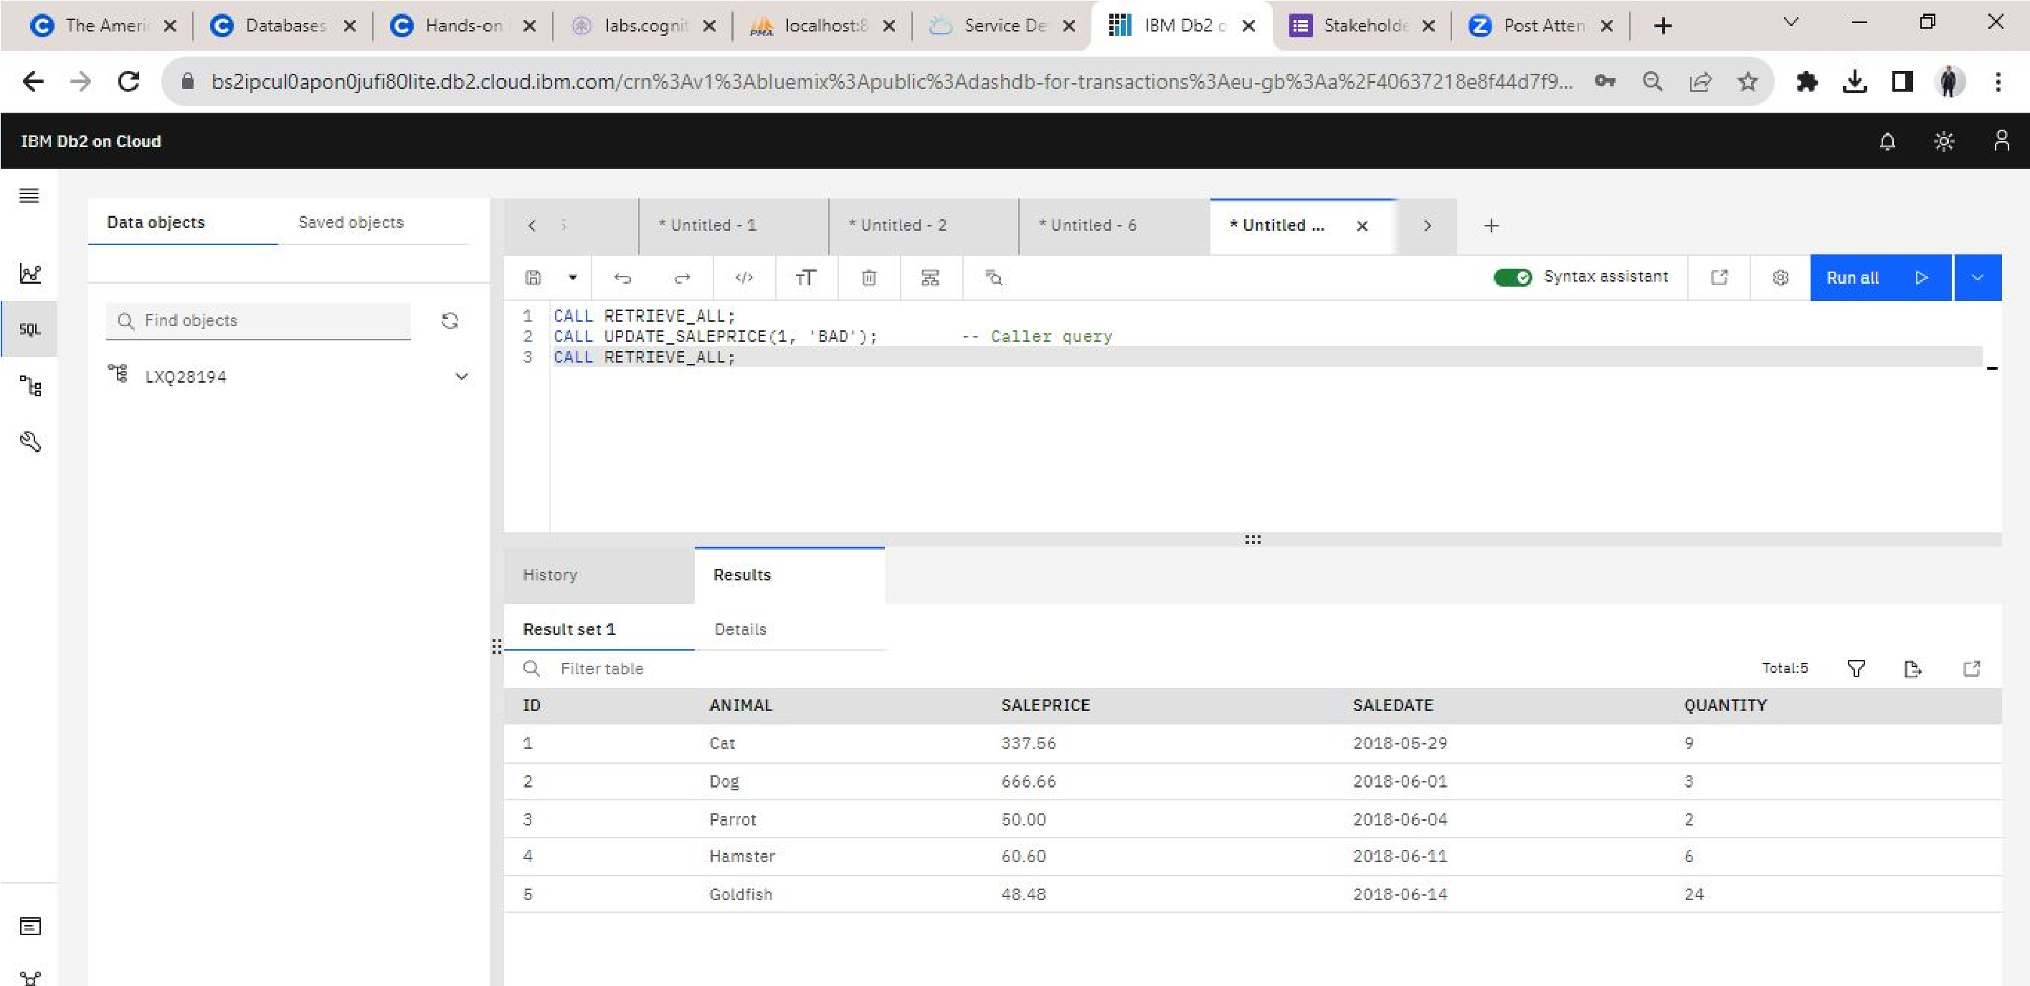

I called the stored procedure with input **parameters 1 and BAD** and the price of **Cat** changed from 450 to 337, returning a 25% decrease in price as stipulated earlier

## Call stored Procedure for PET ID ‘3’ and health condition ‘WORSE’

I called the stored procedure with input **parameters 3 and WORSE** and the price of **Parrot** changed from 50 to 25, returning a 50% decrease in price as stipulated.

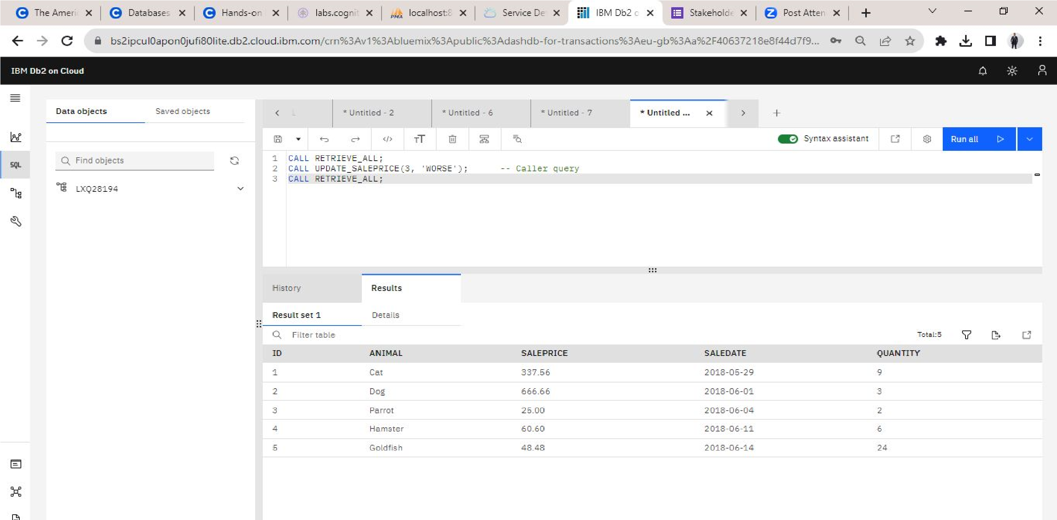

Conclusion

**Stored procedure is a key**

**server query optimisation**

**method for increased**

**transaction speed and**

**database performance,**

**enabling a high degree of**

**security and automation and**

**reducing query redundancy.**

**With this, businesses can**

**automate inventory updates**

**faster.**

## Contact

**Christian Nzeanorue** christian.nzeanorue@gwu.edu

+1 (240)-337-3535